THE UNITED REPUBLIC OF TANZANIA

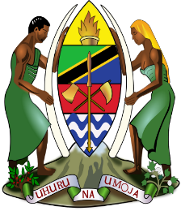 | MINISTRY OF HEALTH  MUHIMBILI NATIONAL HOSPITAL  MLOGANZILA | 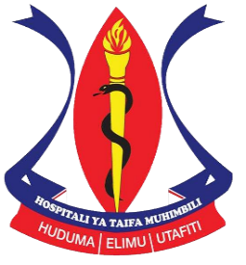

Awareness and acceptability of donor human milk banking among women in Dar es Salaam Tanzania: A cross sectional study
^{1*}Yohana Kimaryo, ¹Lucy L Mpayo, ¹Mwanaidi Amiri Msuya, ¹Robert Moshiro, ¹Judith Lamosai Cosmas

¹Department of Pediatric and Child Health, Muhimbili National Hospital,
Dar es Salaam, Tanzania

https://janeonatology.org/index.php/jan/article/view/97

*Corresponding author: ikundah@gmail.com
Background: Breast milk is the optimal food for all infants in the first months of life. Breastfeeding promotion is crucial in reducing neonatal mortality. World Health Organization recommends donor breast milk as the best alternative when mothers' milk is unavailable. Establishing human milk banks in Africa poses a big challenge due to a lack of awareness about donor milk and existence cultural and religious beliefs. This study assessed awareness and acceptability of donor human milk banking.
Methods: A cross-sectional study was conducted at Muhimbili National Hospital between July 2019 and October 2021. Five hundred- and sixty-two-women receiving care at Muhimbili National Hospital - Upanga, and its branch in Mlongazila were recruited. A pretested data collection form was used to collect information from women and was analyzed using SPSS window version 20.
Results: Four hundred and eighty-six women (86.48%) agreed to donate and 469 (83.45%) agreed to use donor breast milk. Three hundred and fourteen (66.95%) accepted donor human milk banking due to the health benefits of breast milk and 155 (33.05%) due to safety of breast milk. Most participants 495(88%) had never heard of milk donation for banking.
Conclusion: Although community awareness of donor human milk bank is low, acceptance of donor breast milk for use and for banking was high indicating community readiness to utilize Human Milk Banking services.
Keywords: Breastfeeding, Donor Breast Milk, Human Milk Bank, Dar es Salaam, Tanzania.

